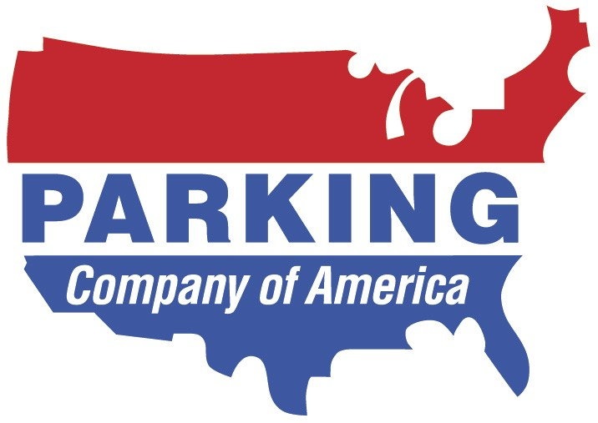

TO: PARKING COMPANY OF AMERICA PAYROLL DEPARTMENT

I hereby agree that I owe Parking Company of America (“PCA”) the amount of $ due to an at fault accident involving a company vehicle
(Vehicle Number & Vin Number)
I assume responsibility for all damages incurred, or the insurance deductible (whichever is less) as a result of this accident, which occurred on , and Location of
(Date of incident)
Incident:
(Street Address; City & State and show lot # also if applicable)

I, hereby authorize PCA’s Payroll Department
(Print full name)
to withhold the total amount of $ from my paychecks. I agree that it will be deducted in increments of $ beginning with pay period ending ,2008 and continue until paid in full.

I agree that if I leave employment with PCA or my employment is terminated for any reason, the balance remaining due and payable on said damage will be deducted from my final paycheck.

I agree that if the final paycheck is not enough to pay for the balance remaining due and payable, I will pay PCA the difference within thirty (30) days of the date of the final paycheck.

I hereby waive any rights I have to the above-reference amount under the Fair Labor Standards Act, and State Payment Statute, or any other statutory or civil tort claim and release Parking Company of America from any liability thereunder.

It is understood that in the event I shall have another at-fault accident, I will be subject to immediate disciplinary action, including suspension and/or termination.

Date:
(Print full name)

(Sign full name)

(Witness sign full name)

(Witness sign full name

